Angel Beats! — Behind the Noise
Description | For 12 years of my life, this guitar solo has been living rent-free in my head. It's from my favorite animated TV show too! I've been wanting to recreate the sound of the solo for the longest time but I can't find the exact fuzz-pedal model that the guitarist used when he recorded this part. I'm sure someone asked about this and it was answered somewhere. Can you find me the fuzz-pedal model?
Files | audio-01.mp3 — a 22.4-second excerpt of the guitar-solo section, with the original backing instruments. Submit RCC{pedal_model}.  ©VisualArt's/Key/Angel Beats! Project
Hint(s) | 1. Follow the original recording sung by Iwasawa’s singing voice, marina.  2. The recording guitarist is 光収容, also written Hikarisyuyo.  3. His old website preserved reader questions alongside diary entries. Look through October 2010.
Walkthrough | 1. Follow “Crow Song,” named in the prompt, to its original Girls Dead Monster single. The supplied clip is 2:11.1–2:33.5 of this recording. The original vocalist is Iwasawa, whose singing voice is marina. The official CD page identifies the single as Crow Song, released April 23, 2010. A contemporary article connects the song to the cafeteria performance in episode 1, “Departure.”  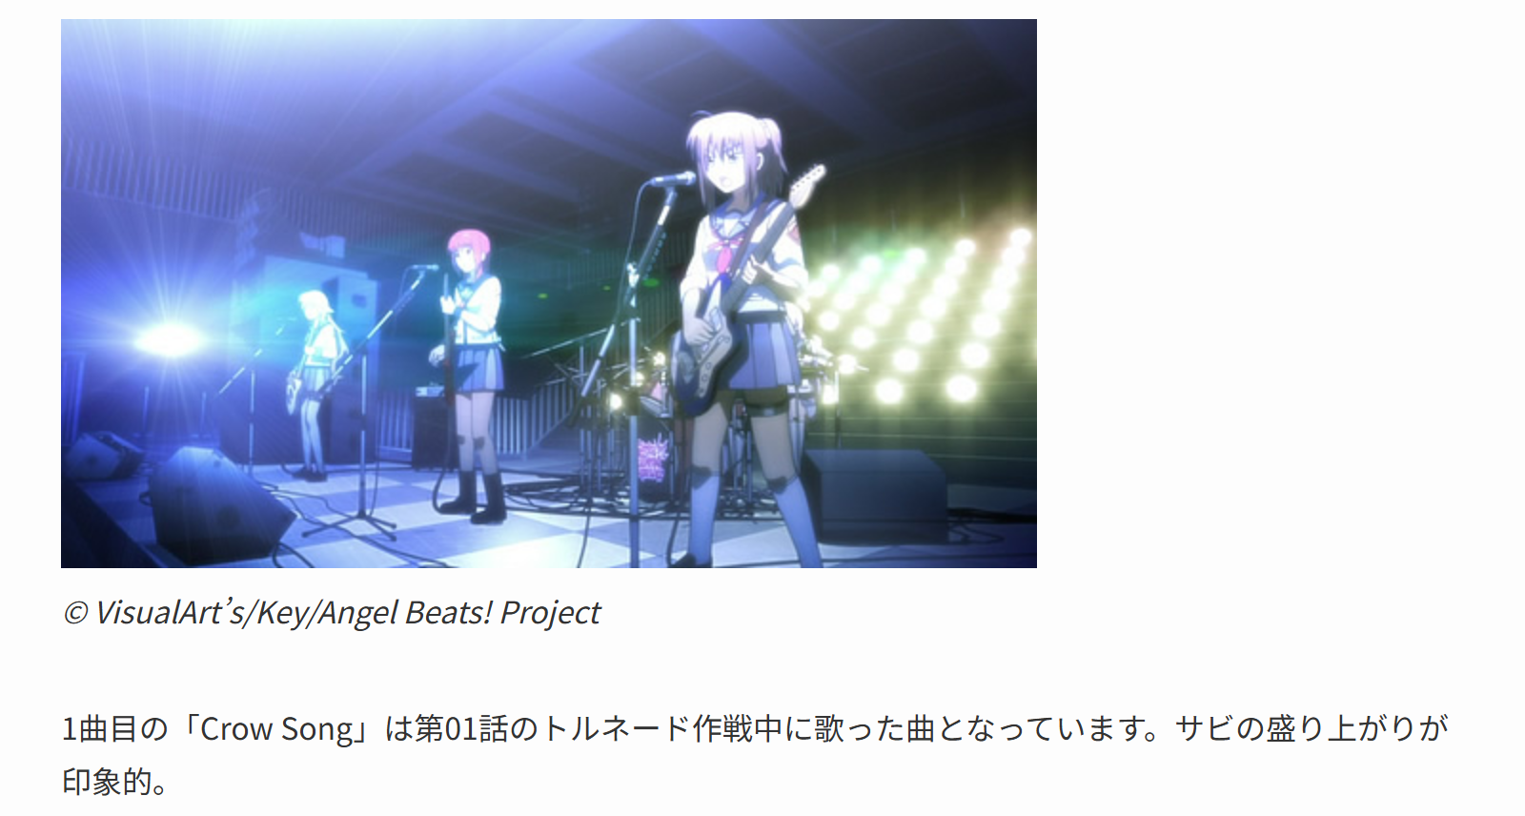  2. Follow the recording credits to 光収容 / Hikarisyuyo. His archived works page credits him with arrangement, guitar and bass for Girls Dead Monster. In his April 30, 2010 diary, he also responds to a fan praising Crow Song’s solo, describing its roaring fuzz as characteristic of his playing.  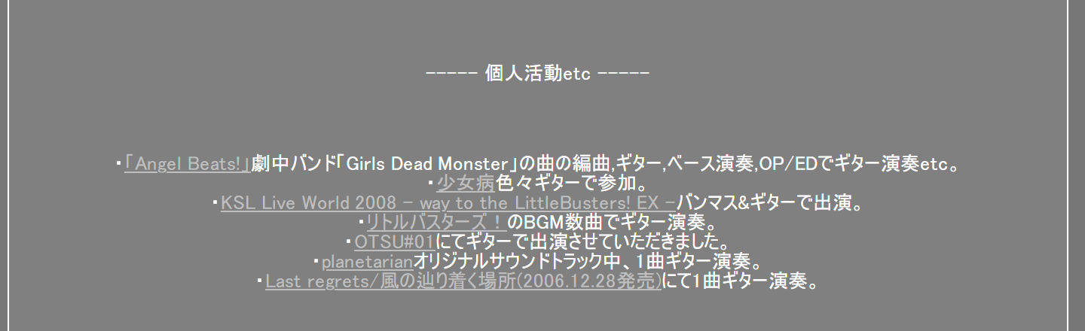  3. Open his archived homepage. Follow Log1012 at the bottom, then Log1010 at the bottom of the December 2010 diary.      4. In the October 2, 2010 entry, find the reader asking which fuzz he used for Crow Song’s solo. His reply, “あれはHSWの1405,” means “That was HSW’s 1405.” The following sentence recommends a Big Muff for a similar sound; the pedal he names as used is HSW 1405.  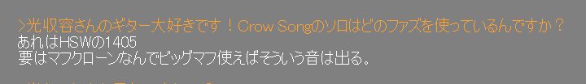  5. Submit HSW 1405. For corroboration, the underside-label photograph in an owner's January 7, 2009 account reads HSW / Honda Sound Works / 1405 / MAD FUZZ. This confirms the expanded model name; the photographed unit belongs to that owner.  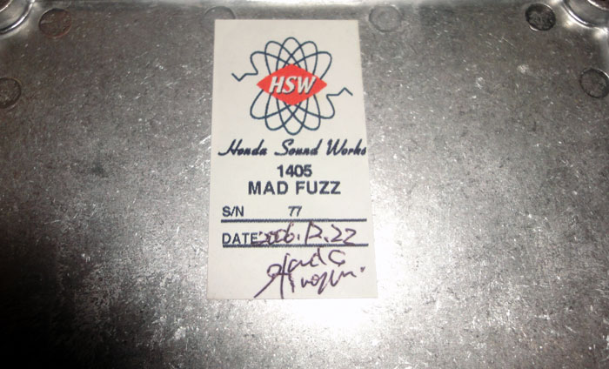
Flag | RCC{hsw_1405}  Accept these answer values inside RCC{...}: 1405, HSW 1405, Honda Sound Works 1405, 1405 Mad Fuzz, HSW 1405 Mad Fuzz, and Honda Sound Works 1405 Mad Fuzz.  Ignore case and surrounding whitespace; treat spaces, underscores and hyphens as equivalent separators. Require 1405. Big Muff, Mad Fuzz alone and other pedal models do not identify the requested model.  Allow three substantive attempts. Staff should correct genuine formatting errors without consuming an attempt.

